Vector Databases Versus Traditional Databases

Vector databases
A vector database is a specialized database designed to store and query vectorized data rapidly. Unlike conventional databases, which organize data in tables, a vector database represents data as vectors in a multi-dimensional space. These vectors encapsulate essential attributes of the items they represent, making vector databases ideal for tasks requiring similarity searches, nearest neighbor queries, and assessing distances or similarities between vectors.

Vector databases data storage
Vector databases store data formatted so that numerical vectors depict each data item. These numbers signify various attributes or features of the object, with each vector dimension corresponding to a specific attribute. For instance, in an image database, each image may be represented as a vector of pixel values, while a text database might represent each piece of text as a vector of word frequencies.
In the following illustration you can see that you can take images, text (including text strings), and audio, then apply the appropriate transformer to create vector embeddings, and then store the data in vector databases for further use.
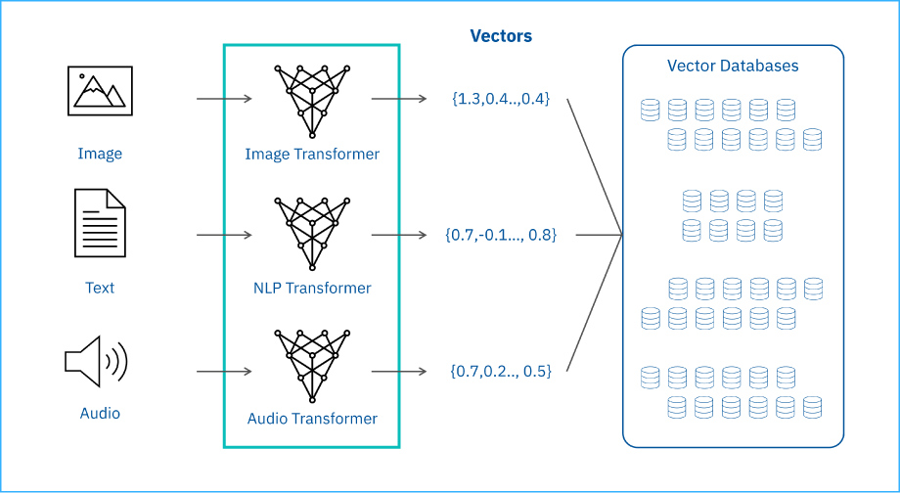

Vector libraries
Vector libraries within in-memory vector databases. Besides libraries, Vector databases use pre-configured algorithms to store and update data. You'll find commercially available vector libraries for similarity. In contrast, vector databases have full CRUD (create, read, update, and delete) capabilities. Additionally, vector databases are often a part of enterprise-level production deployments.

Relational database organization
A relational database organizes data into tables, utilizing rows and columns. Relational databases use structured query language (SQL) for data querying and manipulation, adhering to the relational model. Relational databases excel in managing structured data where relationships between different entities are well-defined.

Relational database data storage
Relational databases store data in tables, each representing a distinct entity or relationship.
Each row in a table corresponds to a record, while each column represents a property or attribute. Tables contain data and get connected, having relationships. With other tables using keys, such as main and foreign keys.
In a relational database, users can perform transactions, queries, and internal processes on stored data or objects (database files) within rows and columns of tables.
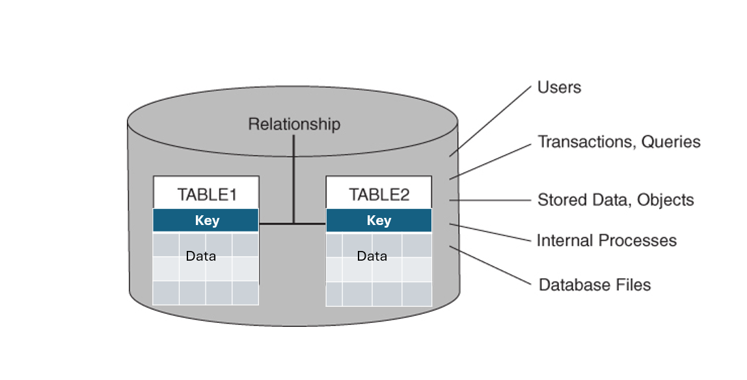
The database structures data in these tables and establishes connections between the tables using keys identified as primary and foreign keys. A relational database query manipulates the rows and columns using SELECT, INSERT, UPDATE, and DELETE operations.

Vector and relational databases compared
Check out this comparative table to understand the distinctions between vector and relational databases, which is crucial for selecting the appropriate database type for specific needs.
Function | Traditional databases | Vector databases
Data Representation | Traditional databases organize data in a structured format using tables, rows, and columns, ideal for relational data. | Vector databases represent data as multi-dimensional  vectors, efficiently encoding complex and unstructured data  like images, text, and sensor data.
Data Search and Retrieval | SQL queries are suited for traditional databases with structured data. | Vector databases specialize in similarity searches and  retrieving vectorized data, facilitating tasks like image  retrieval, recommendation systems, and anomaly detection.
Indexing | Traditional databases employ indexing methods like B-trees for efficient data retrieval. | Vector databases use indexing structures like metric trees  and hashing suited for high-dimensional spaces, enhancing  nearest-neighbor searches and similarity assessments.
Scalability | Scaling traditional databases can be challenging, often requiring resource augmentation or data sharding. | Vector databases are designed for scalability, especially in  handling large datasets and similarity searches, using  distributed architectures for horizontal scaling.
Applications | Traditional databases are pivotal in business applications and transactional systems where structured data is processed. | Vector databases shine in analyzing vast datasets,  supporting fields like scientific research, natural language  processing, and multimedia analysis.

Recap
In this reading, you learned that:
- A vector database is a specialized database representing data numerically as vectors in a multi-dimensional space.
- While traditional databases are adept at managing structured data and transactional operations, vector databases handle high-dimensional data and perform rapid similarity searches.
- Vector libraries read and update data; however, vector databases can perform create, read, update, and delete (CRUD) functions.
- Vector databases store data formatted so that numerical vectors depict each data item.
- Relational databases organize data into tables, utilizing rows and columns.
- Traditional databases use SQL queries, and vector databases use similarity search to retrieve data.

